**Supplementary Materials for Projected changes in persistent extreme summer weather events: The role of quasi-resonant amplification by CMIP5 and CMIP6 models**

**Mann et al., 2022**

**Produced by Sullyandro Guimarães**

**Sections**

1. **Main results**
2. **Temperature (TAS)**
3. **Temperature anomaly**
4. **Temperature anomaly by latitude and Arctic amplification**
5. **Temperature QRA index (not rescaled)**
6. **Temperature QRA index (rescaled)**
7. **Temperature QRA index onto UA**
8. **Temperature QRA index – trend by model**
   1. **CMIP5** - RCP85 -> Trend for 2015-2050
   2. **CMIP5** - RCP85 -> Trend for 2051-2100
   3. **CMIP6** – SSP585 -> Trend for 2015-2050
   4. **CMIP6** – SSP585 -> Trend for 2051-2100
9. **Main results**

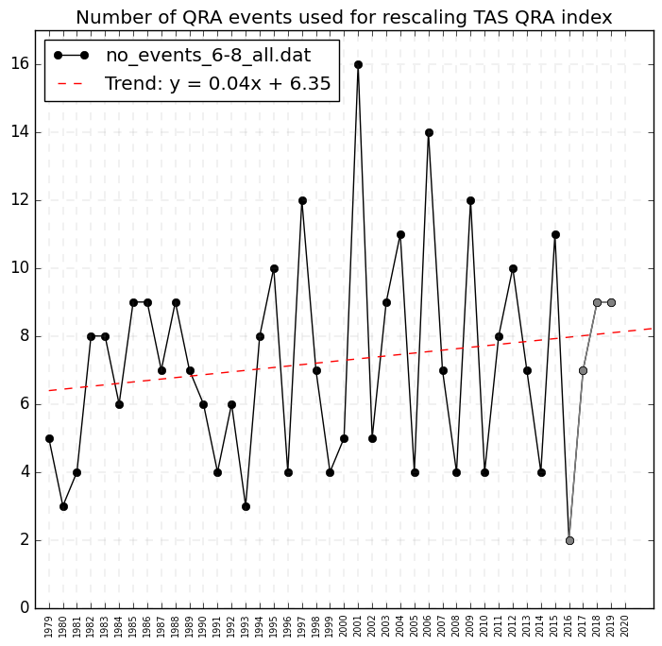

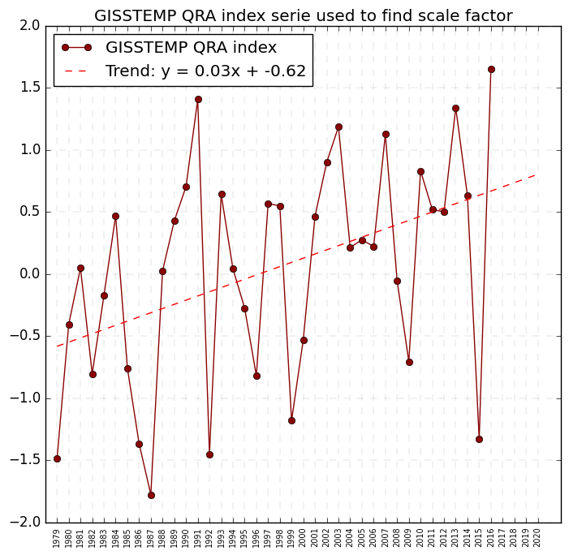

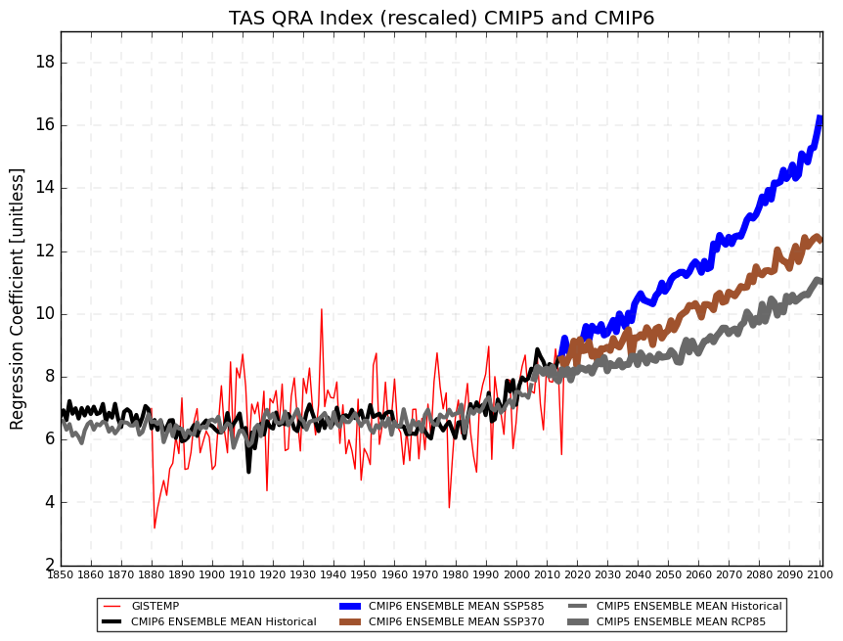

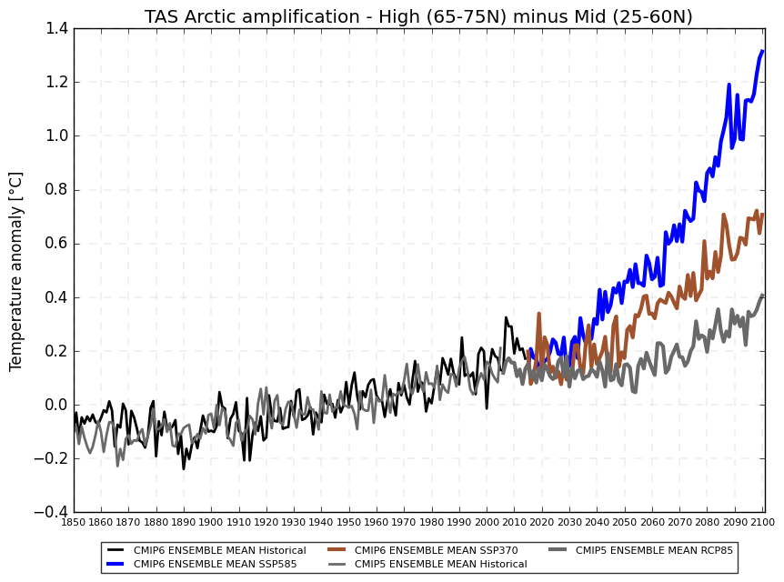

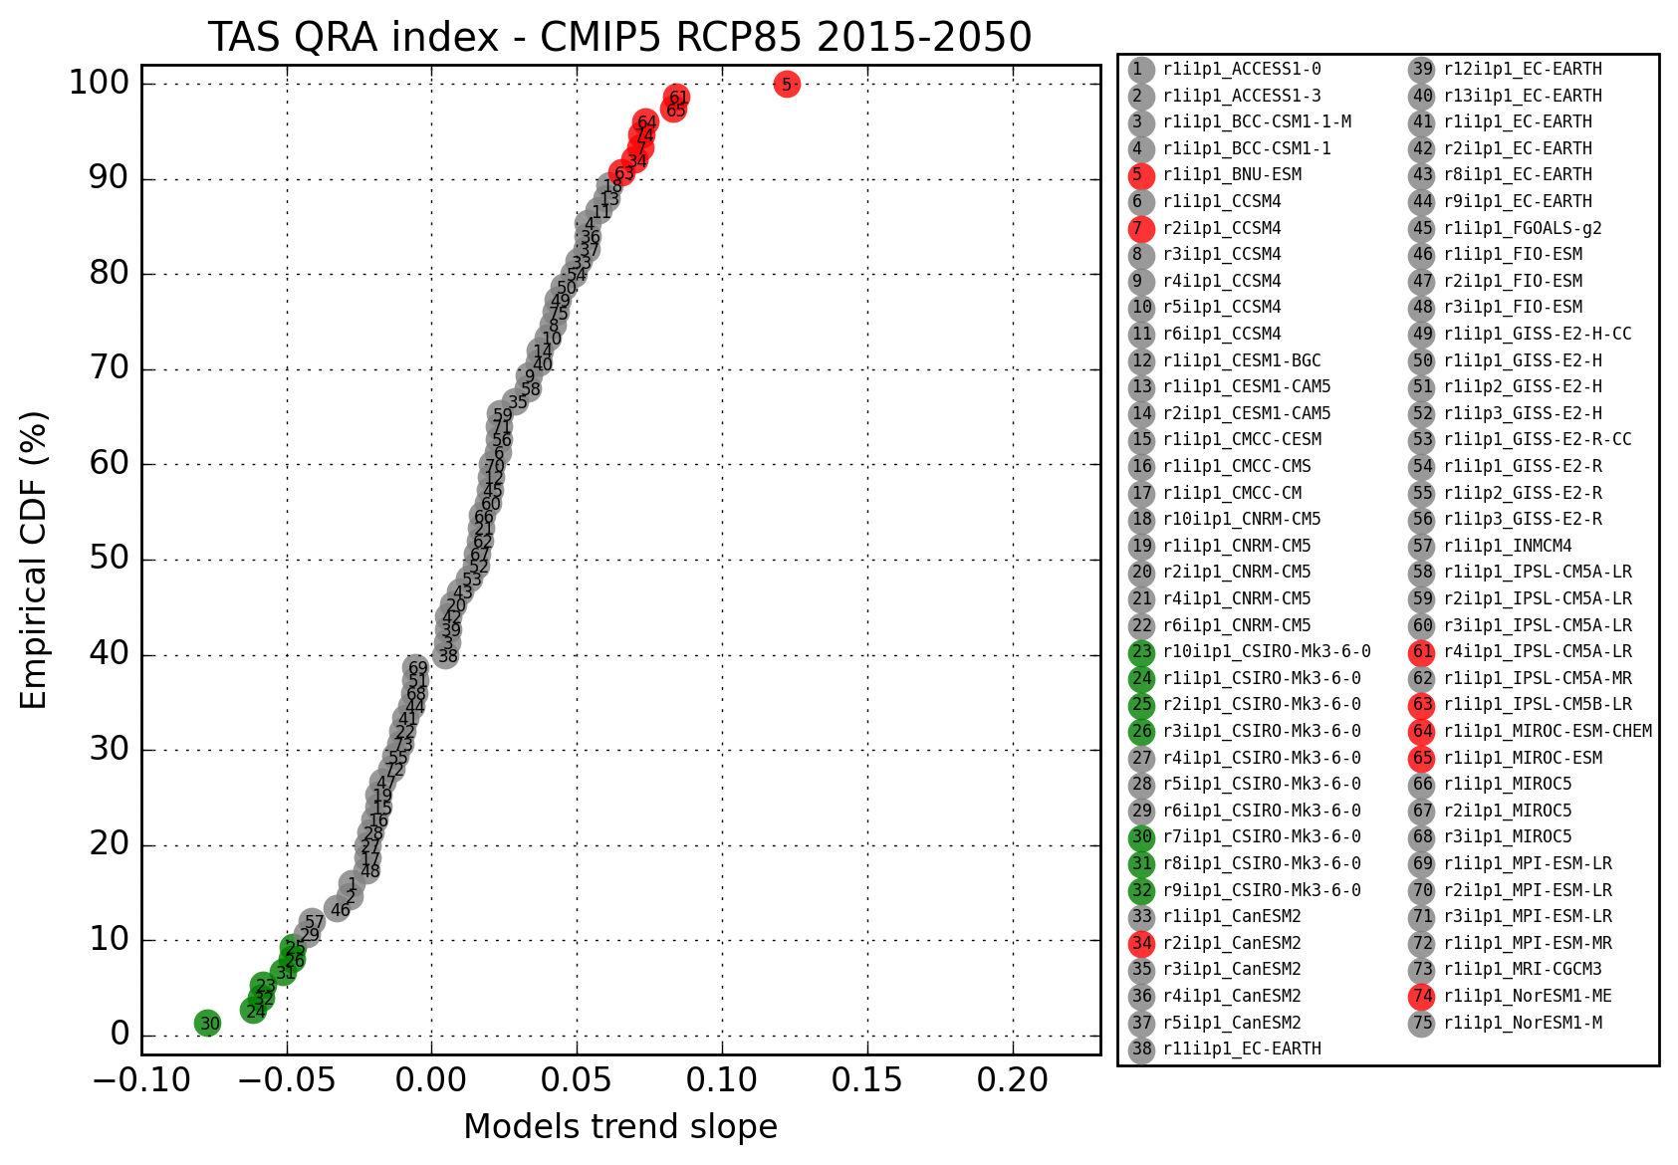

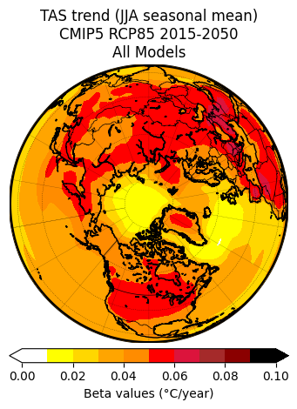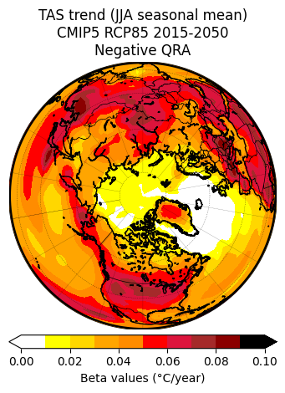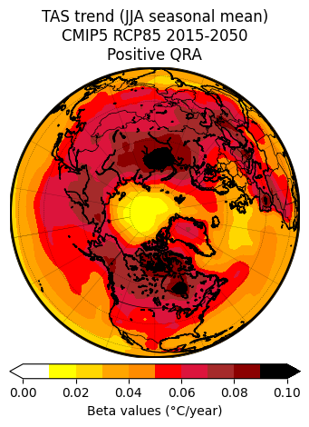

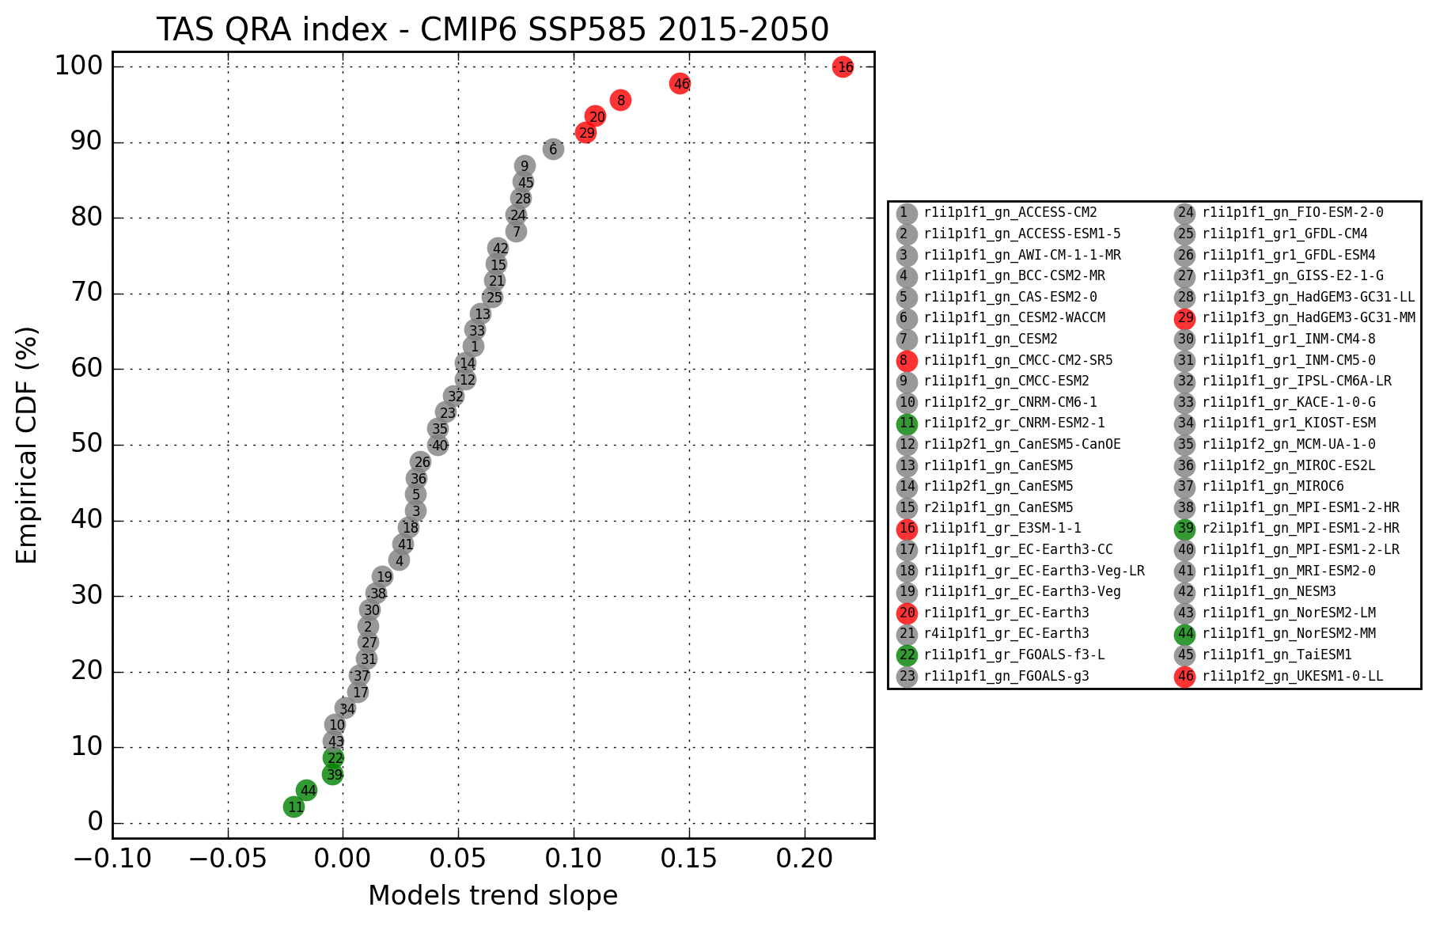

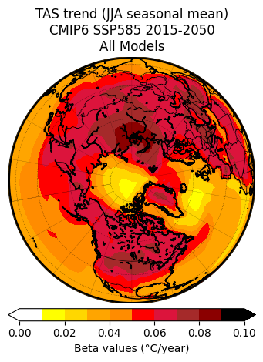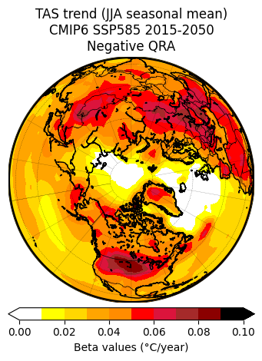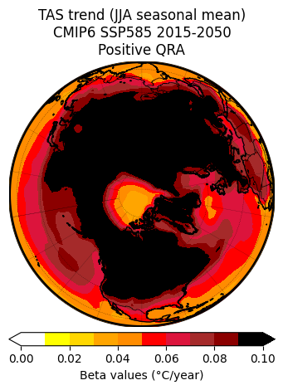

_________________________________ CMIP5 ________________________________



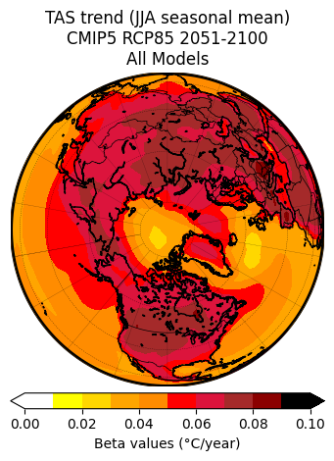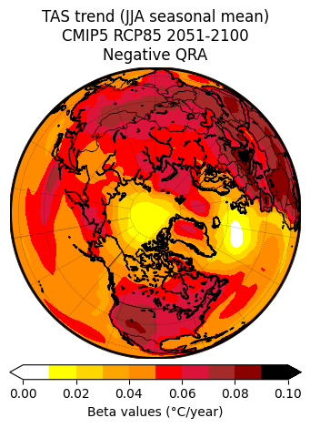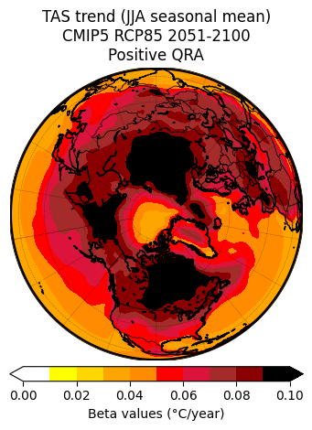

_________________________________ CMIP6 ________________________________



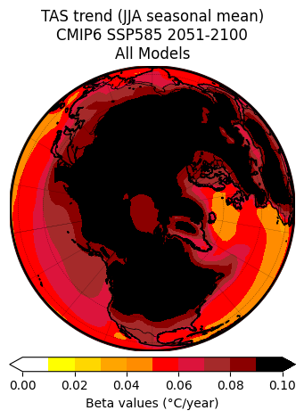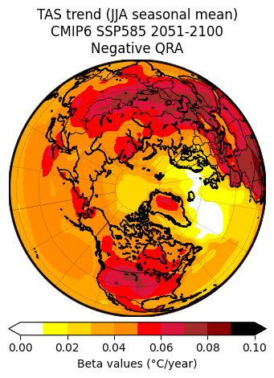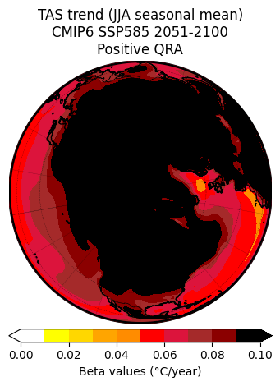

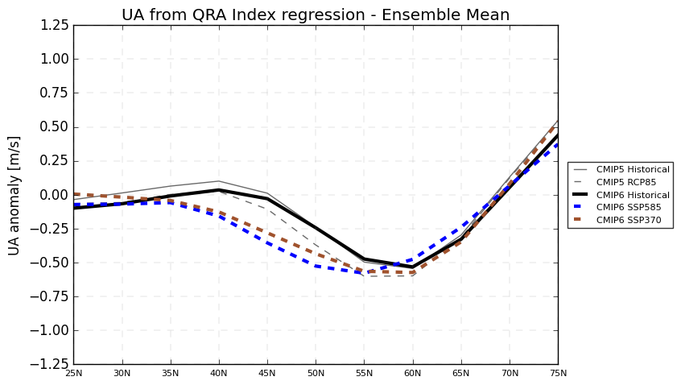

1. **Temperature (TAS)**

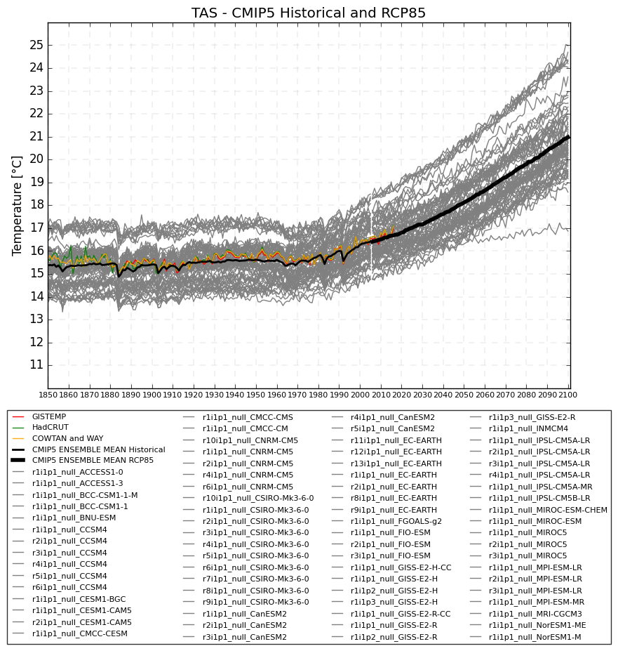

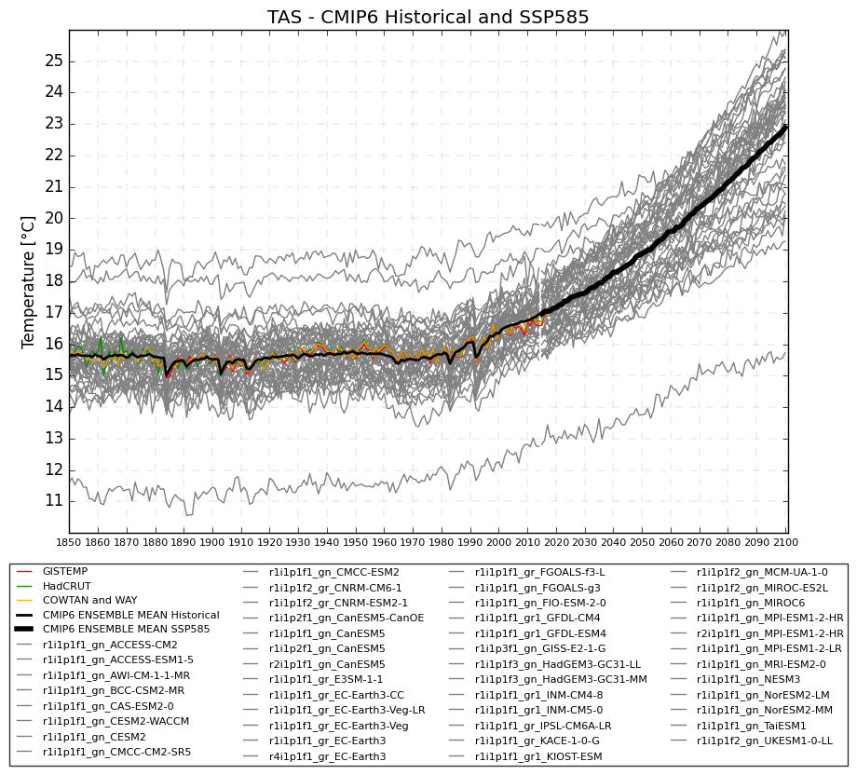

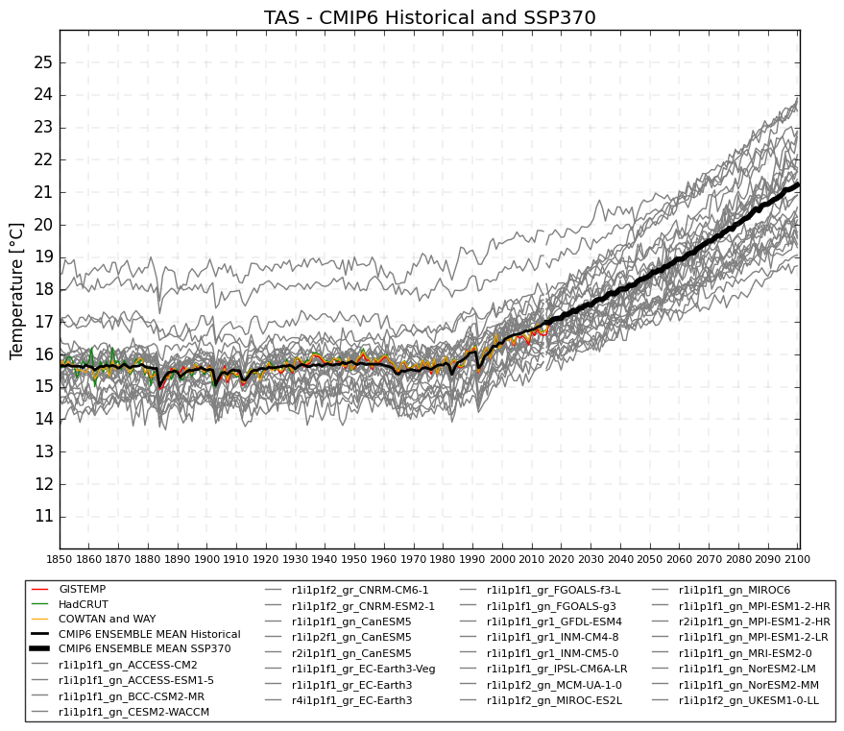

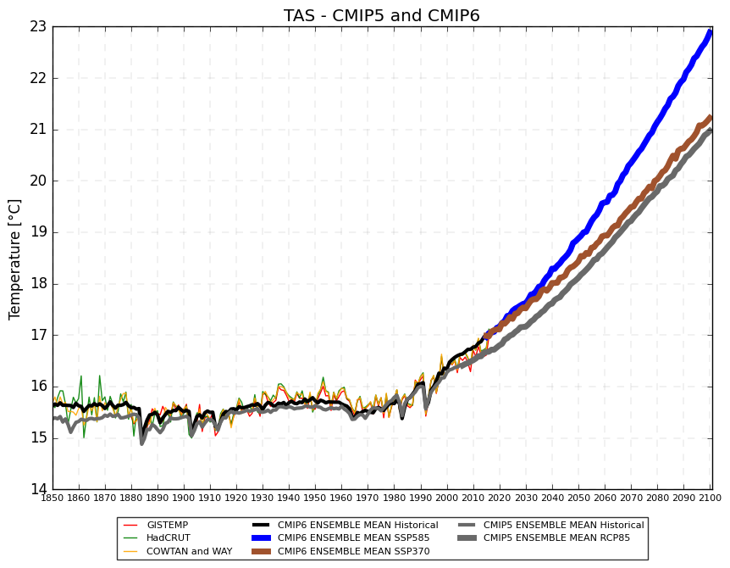

1. **Temperature anomaly**

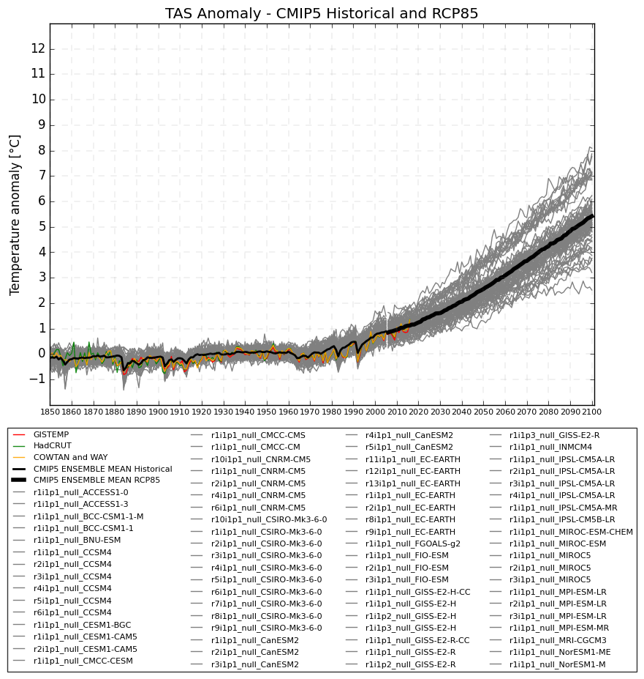

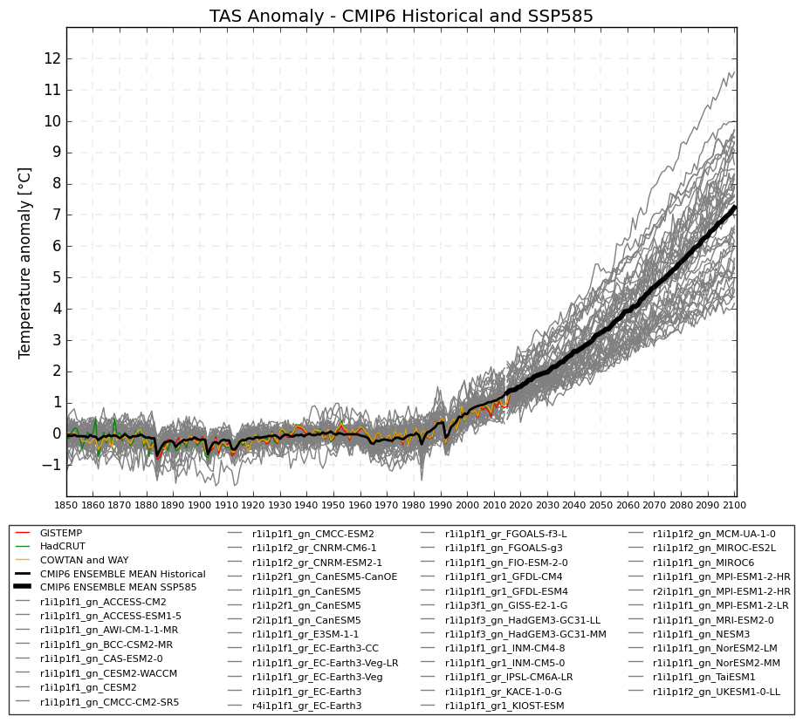

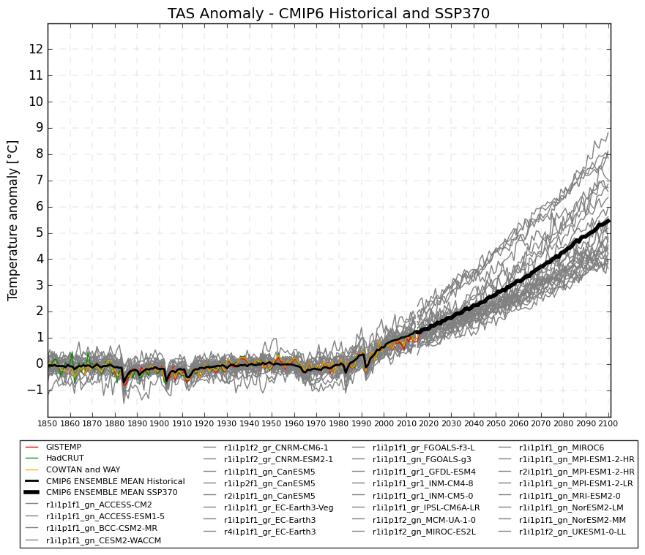

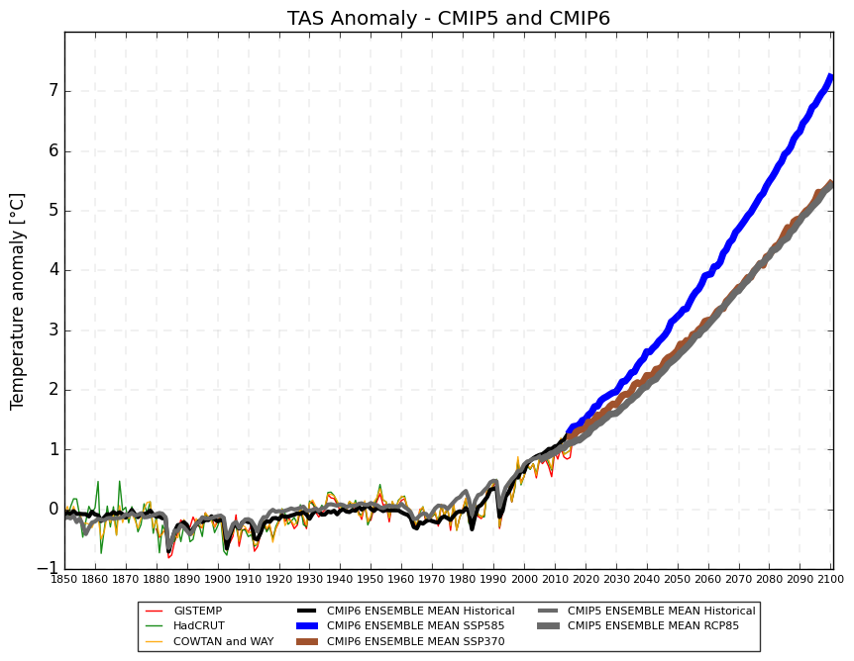

1. **Temperature anomaly by latitude and Arctic amplification**

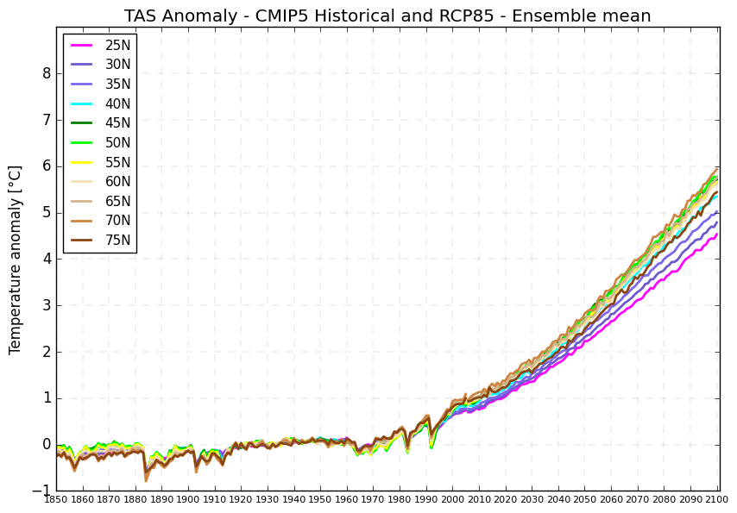

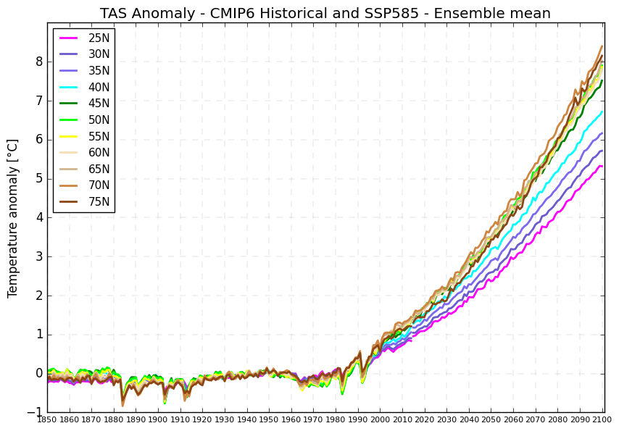

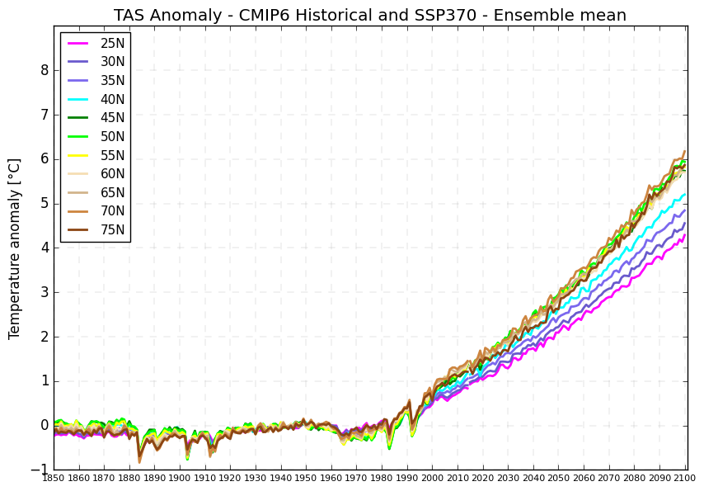

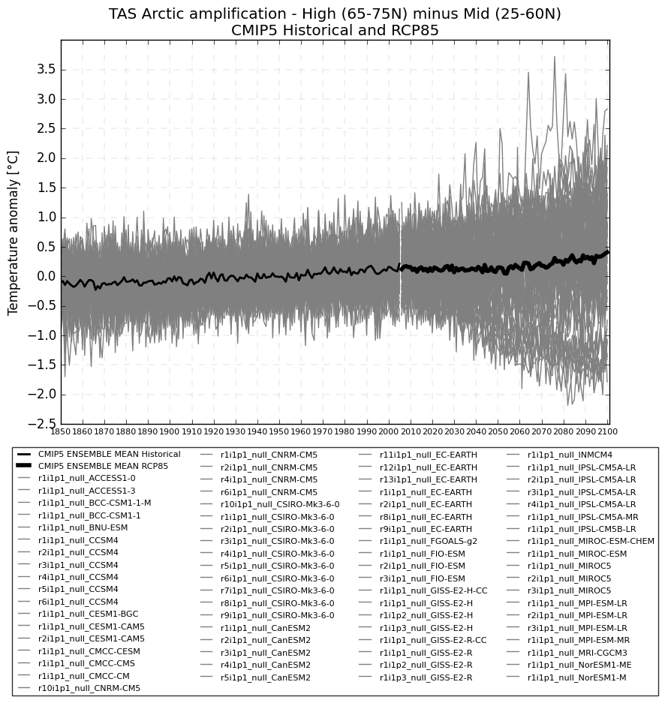

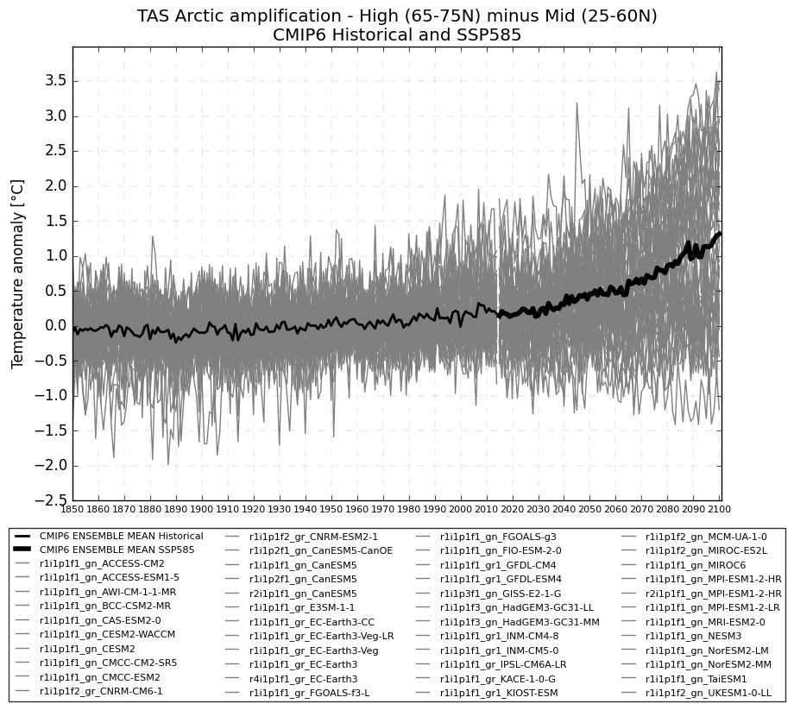

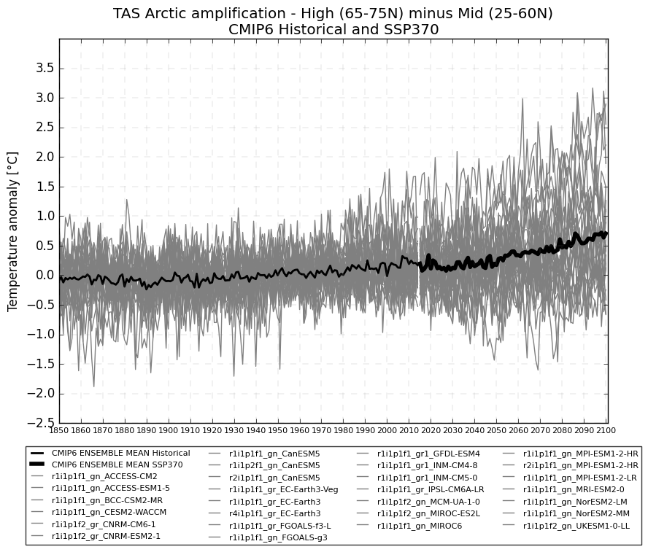



1. **Temperature QRA index (not rescaled)**

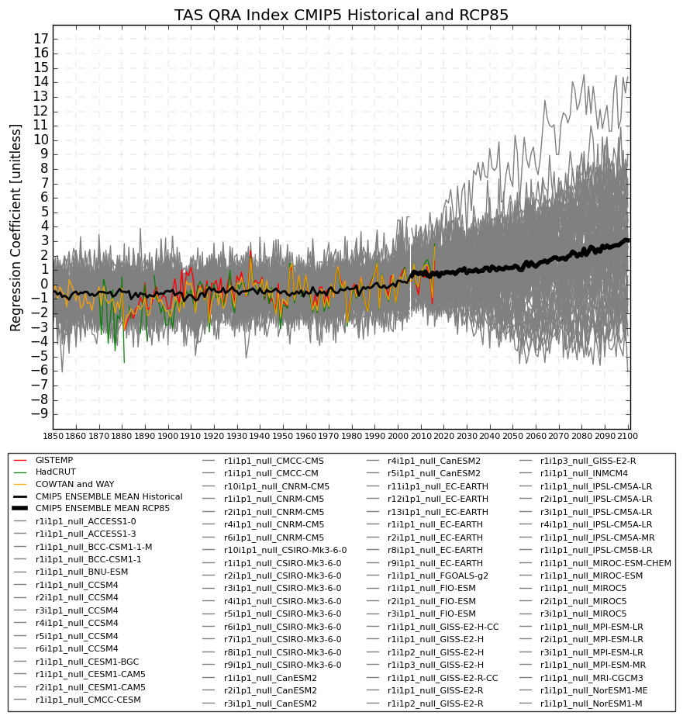

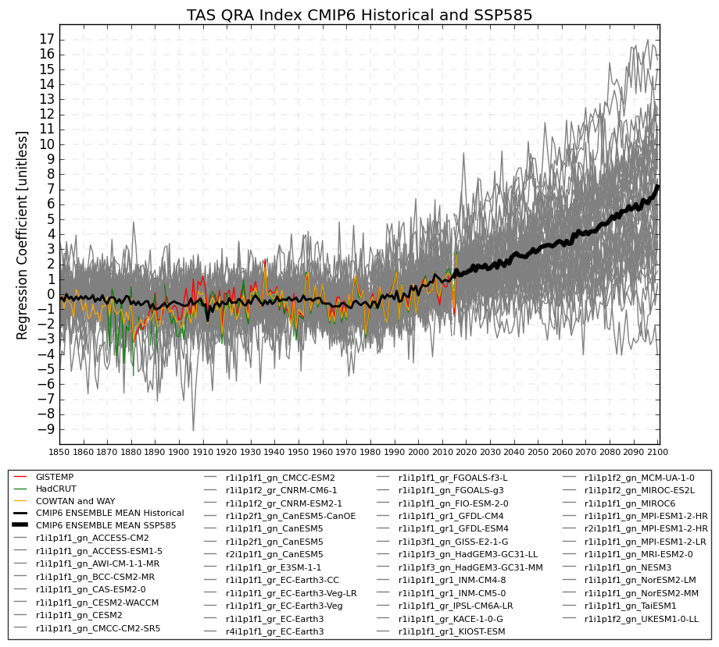

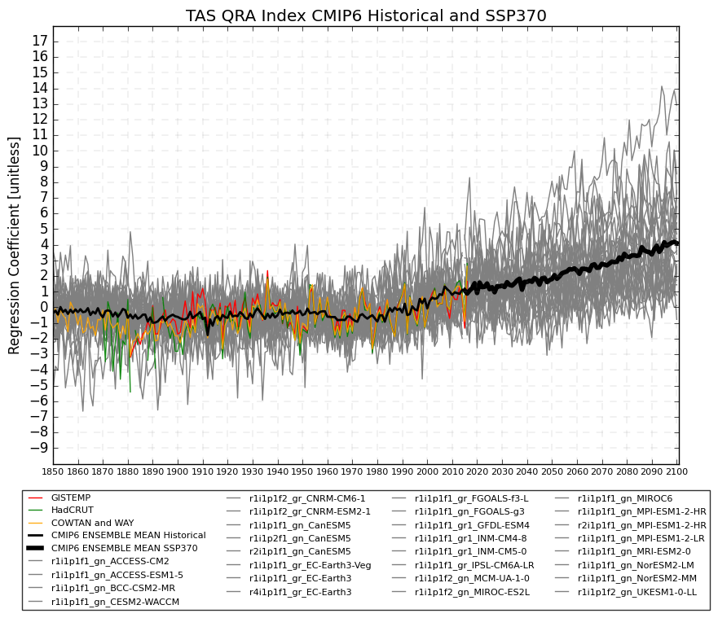

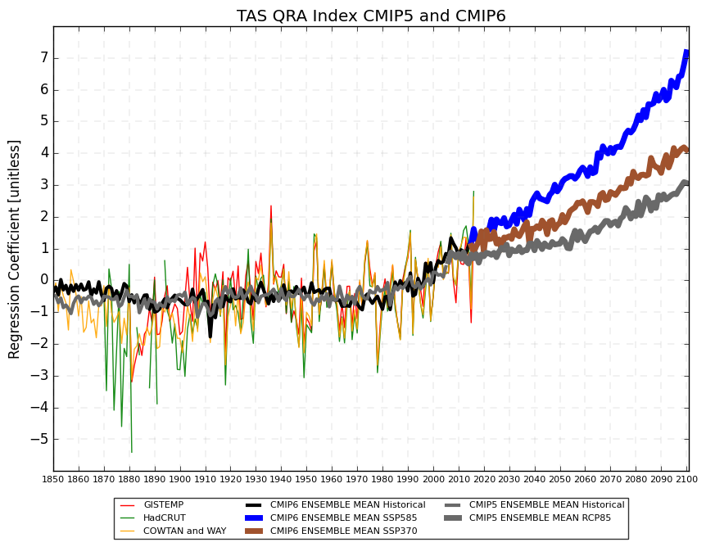

1. **Temperature QRA index (rescaled)**

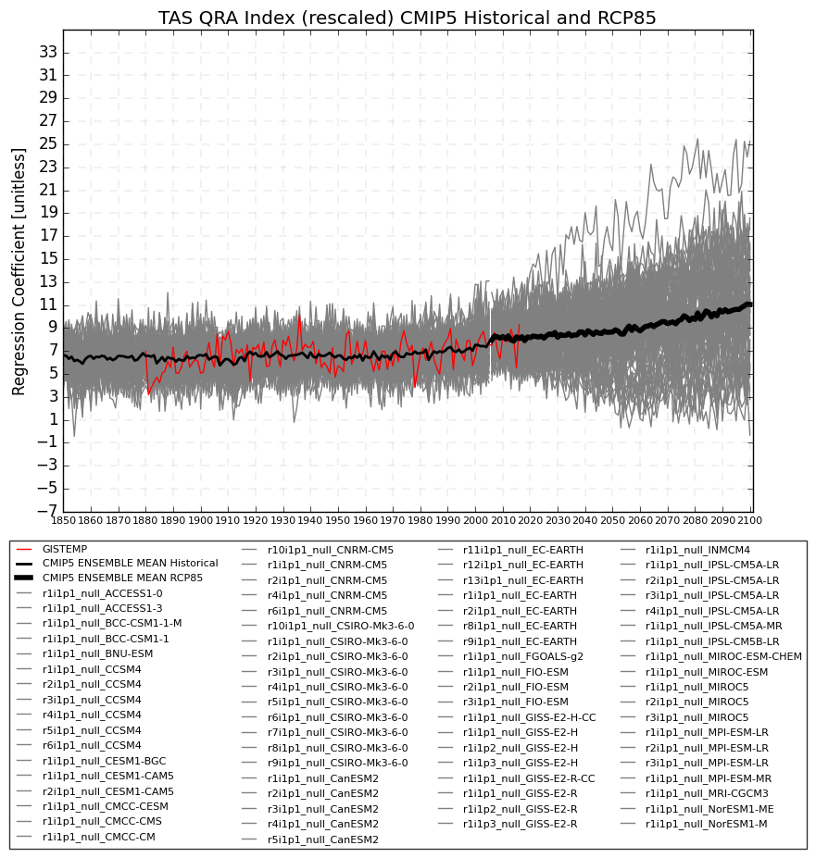

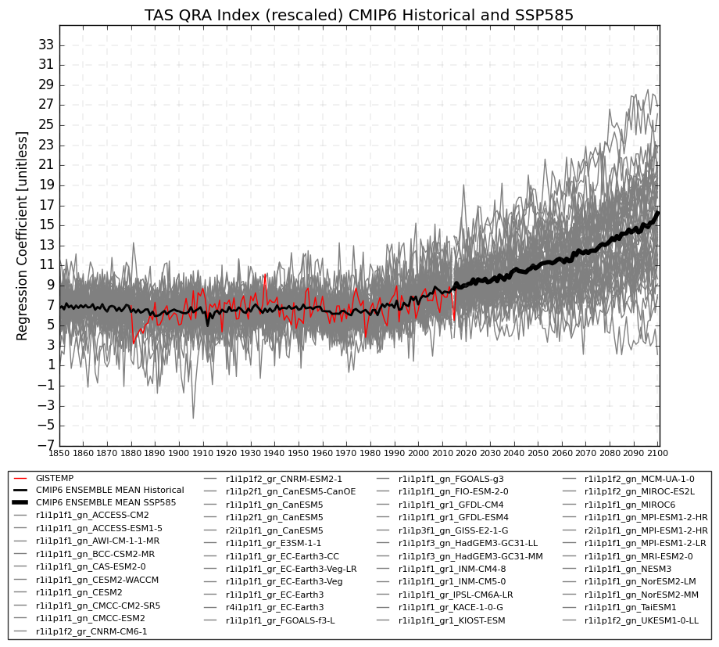

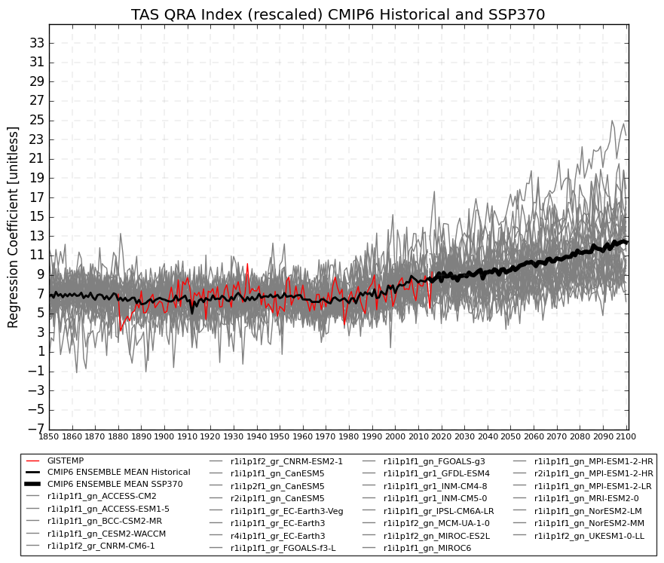



1. **Temperature QRA index onto UA**

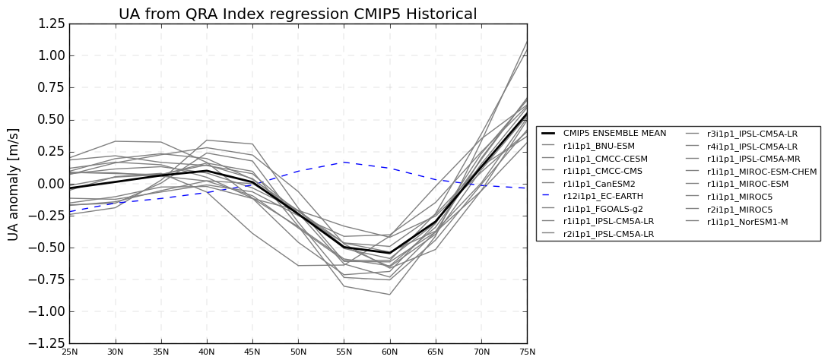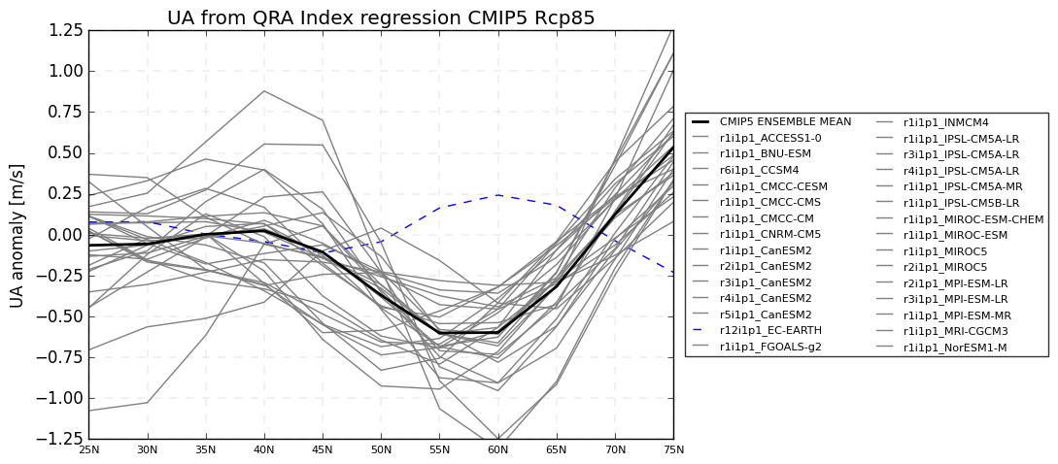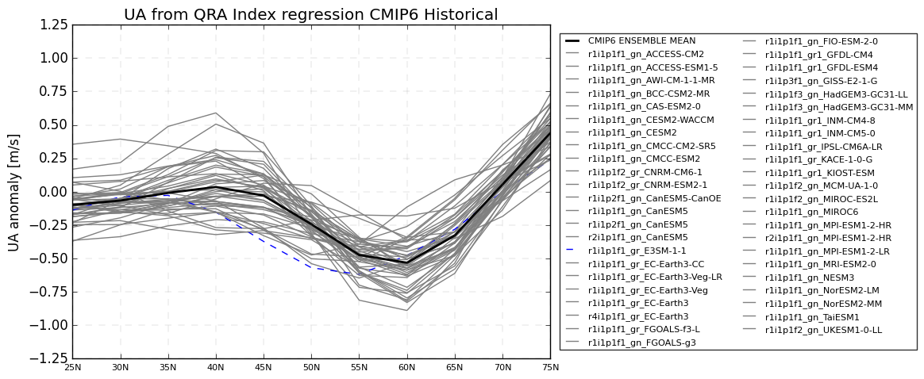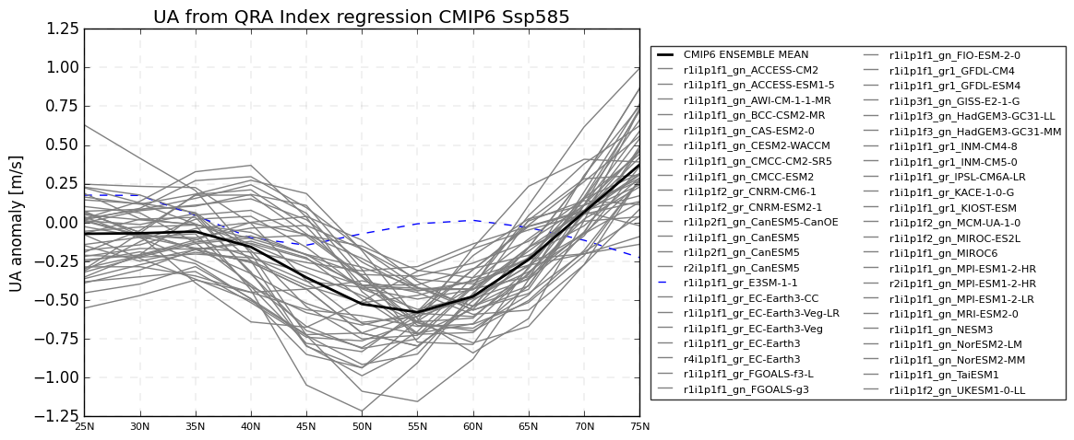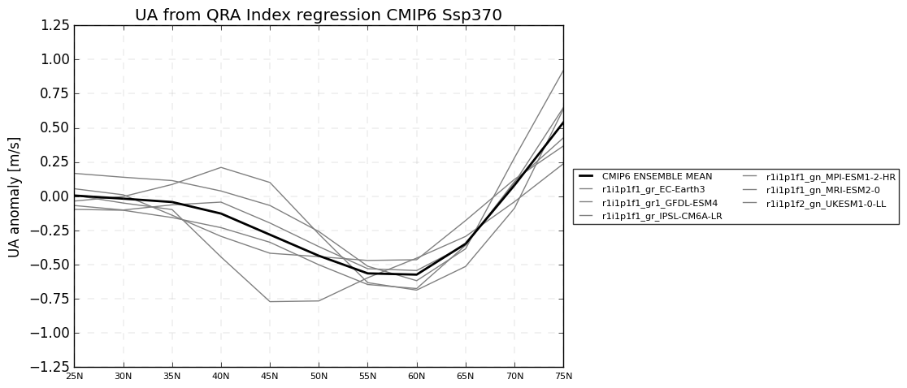

1. **Temperature QRA index – trend by model**

**9.1 CMIP5** - RCP85 -> Trend for 2015-2050

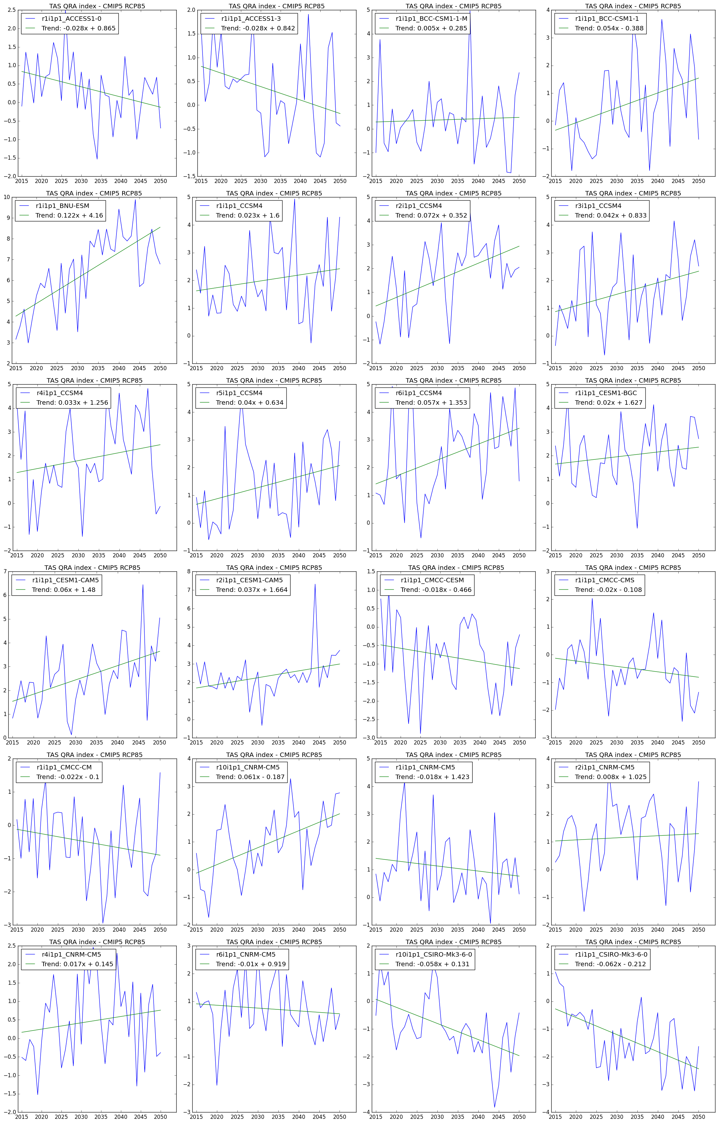

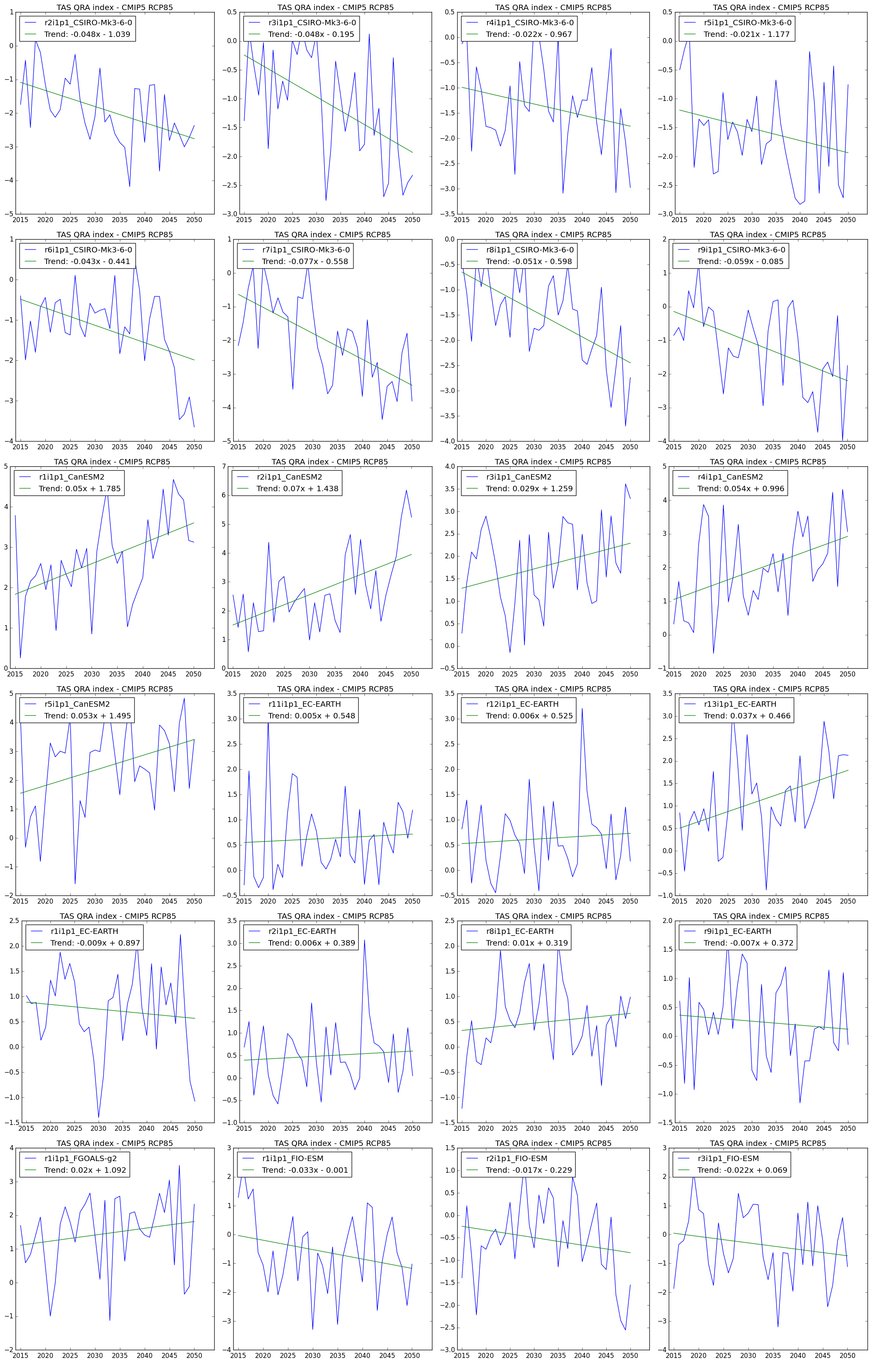

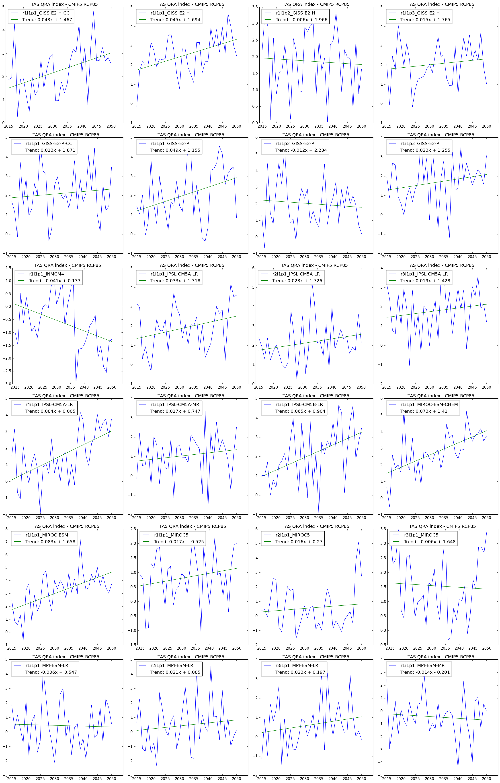

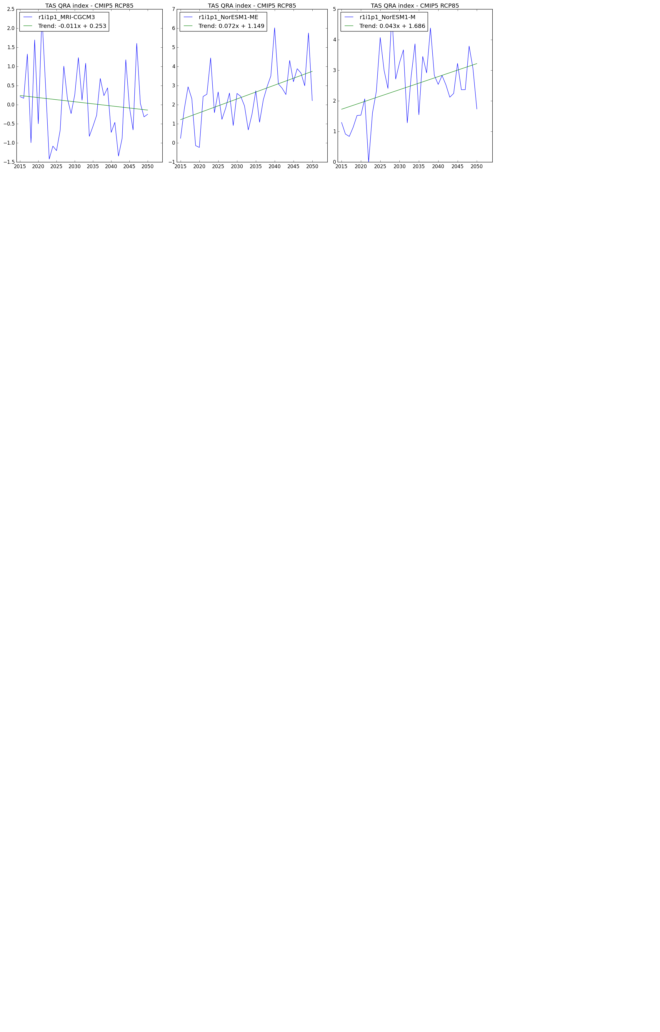

**9.2 CMIP5** - RCP85 -> Trend for 2051-2100

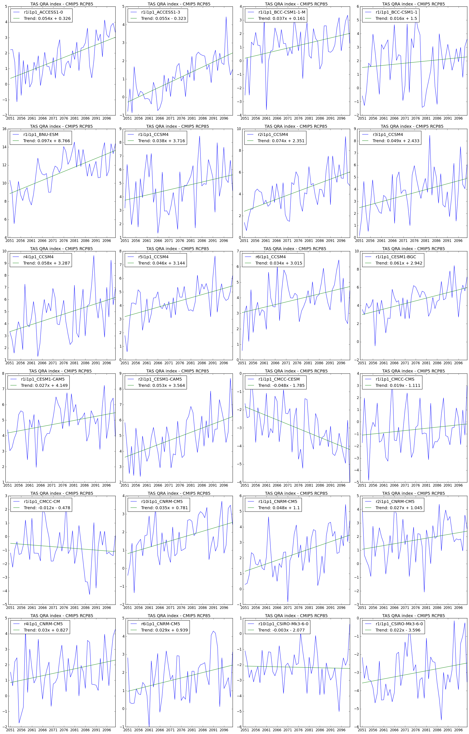

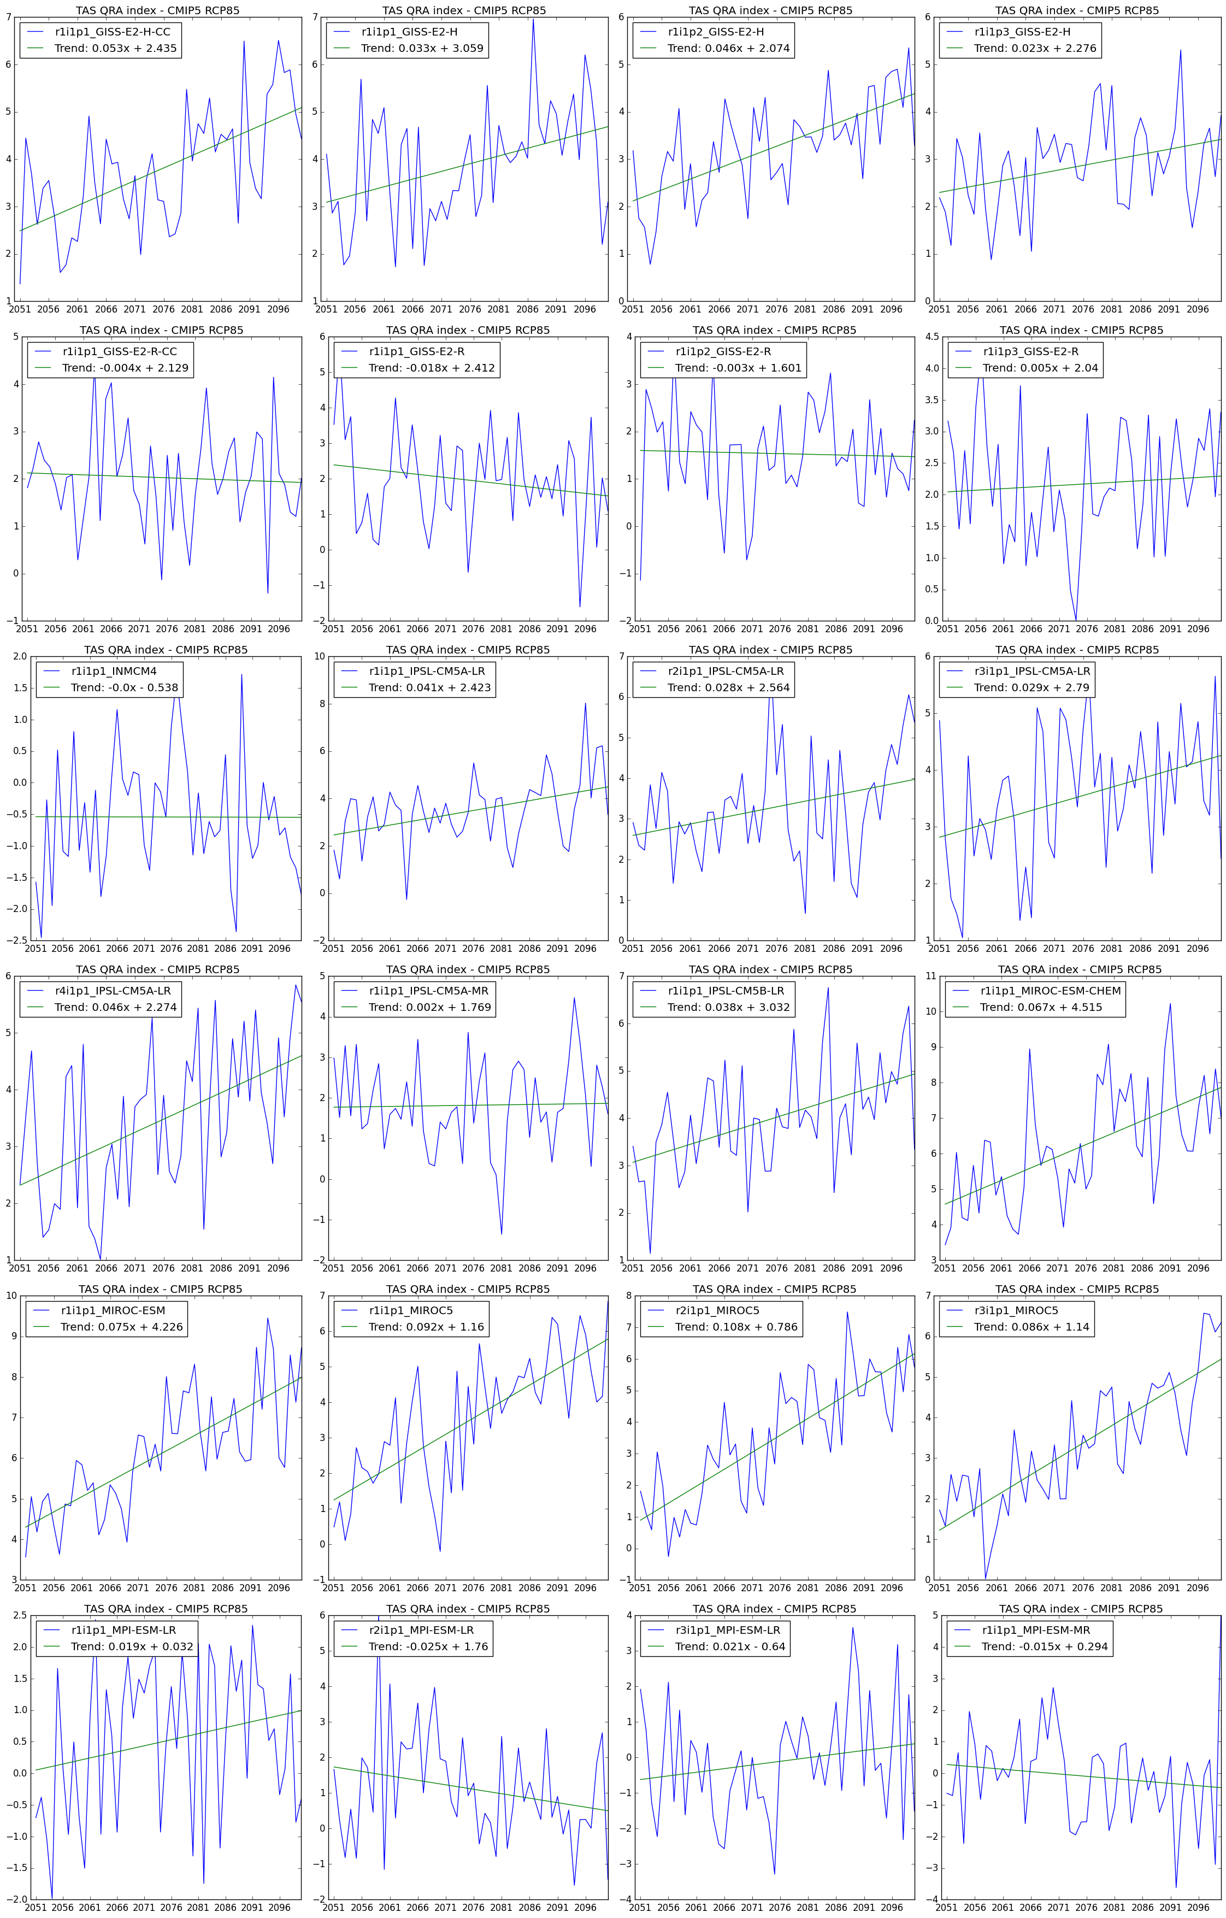

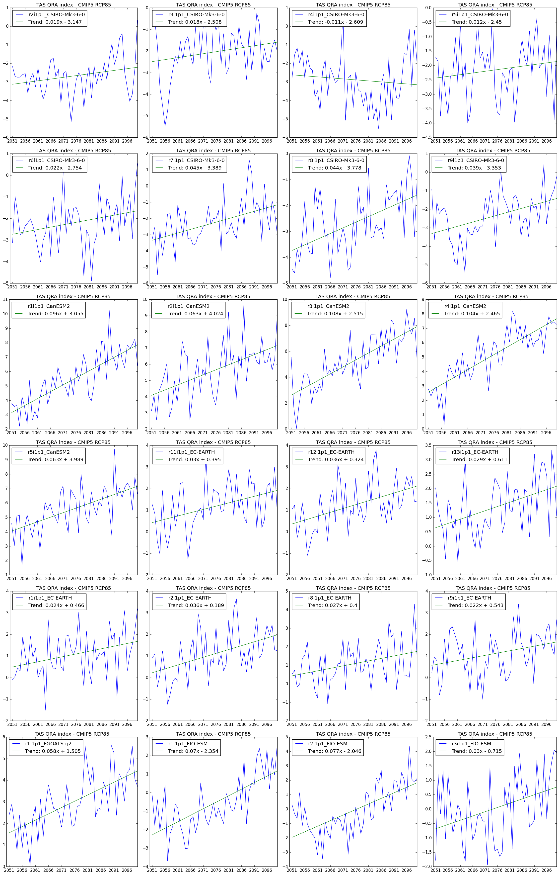

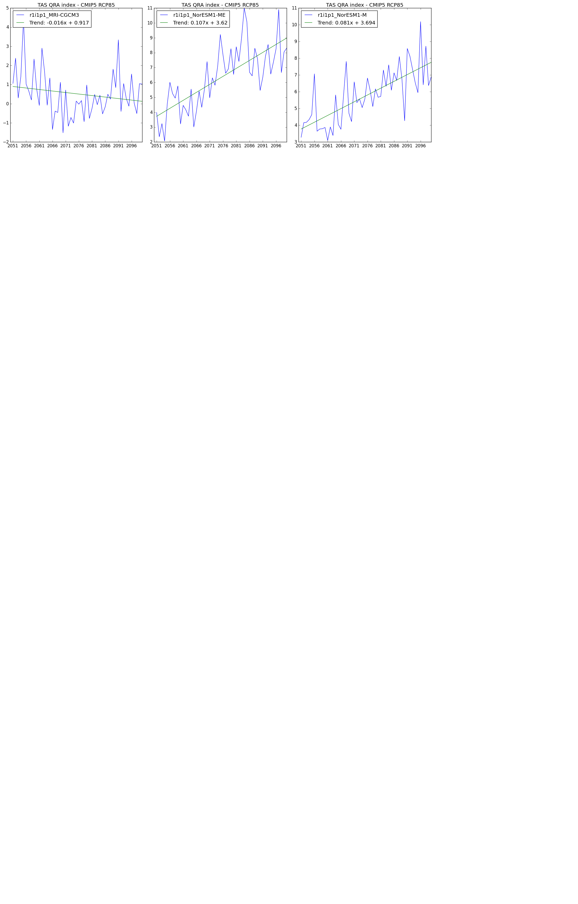

**9.3 CMIP6** – SSP585 -> Trend for 2015-2050

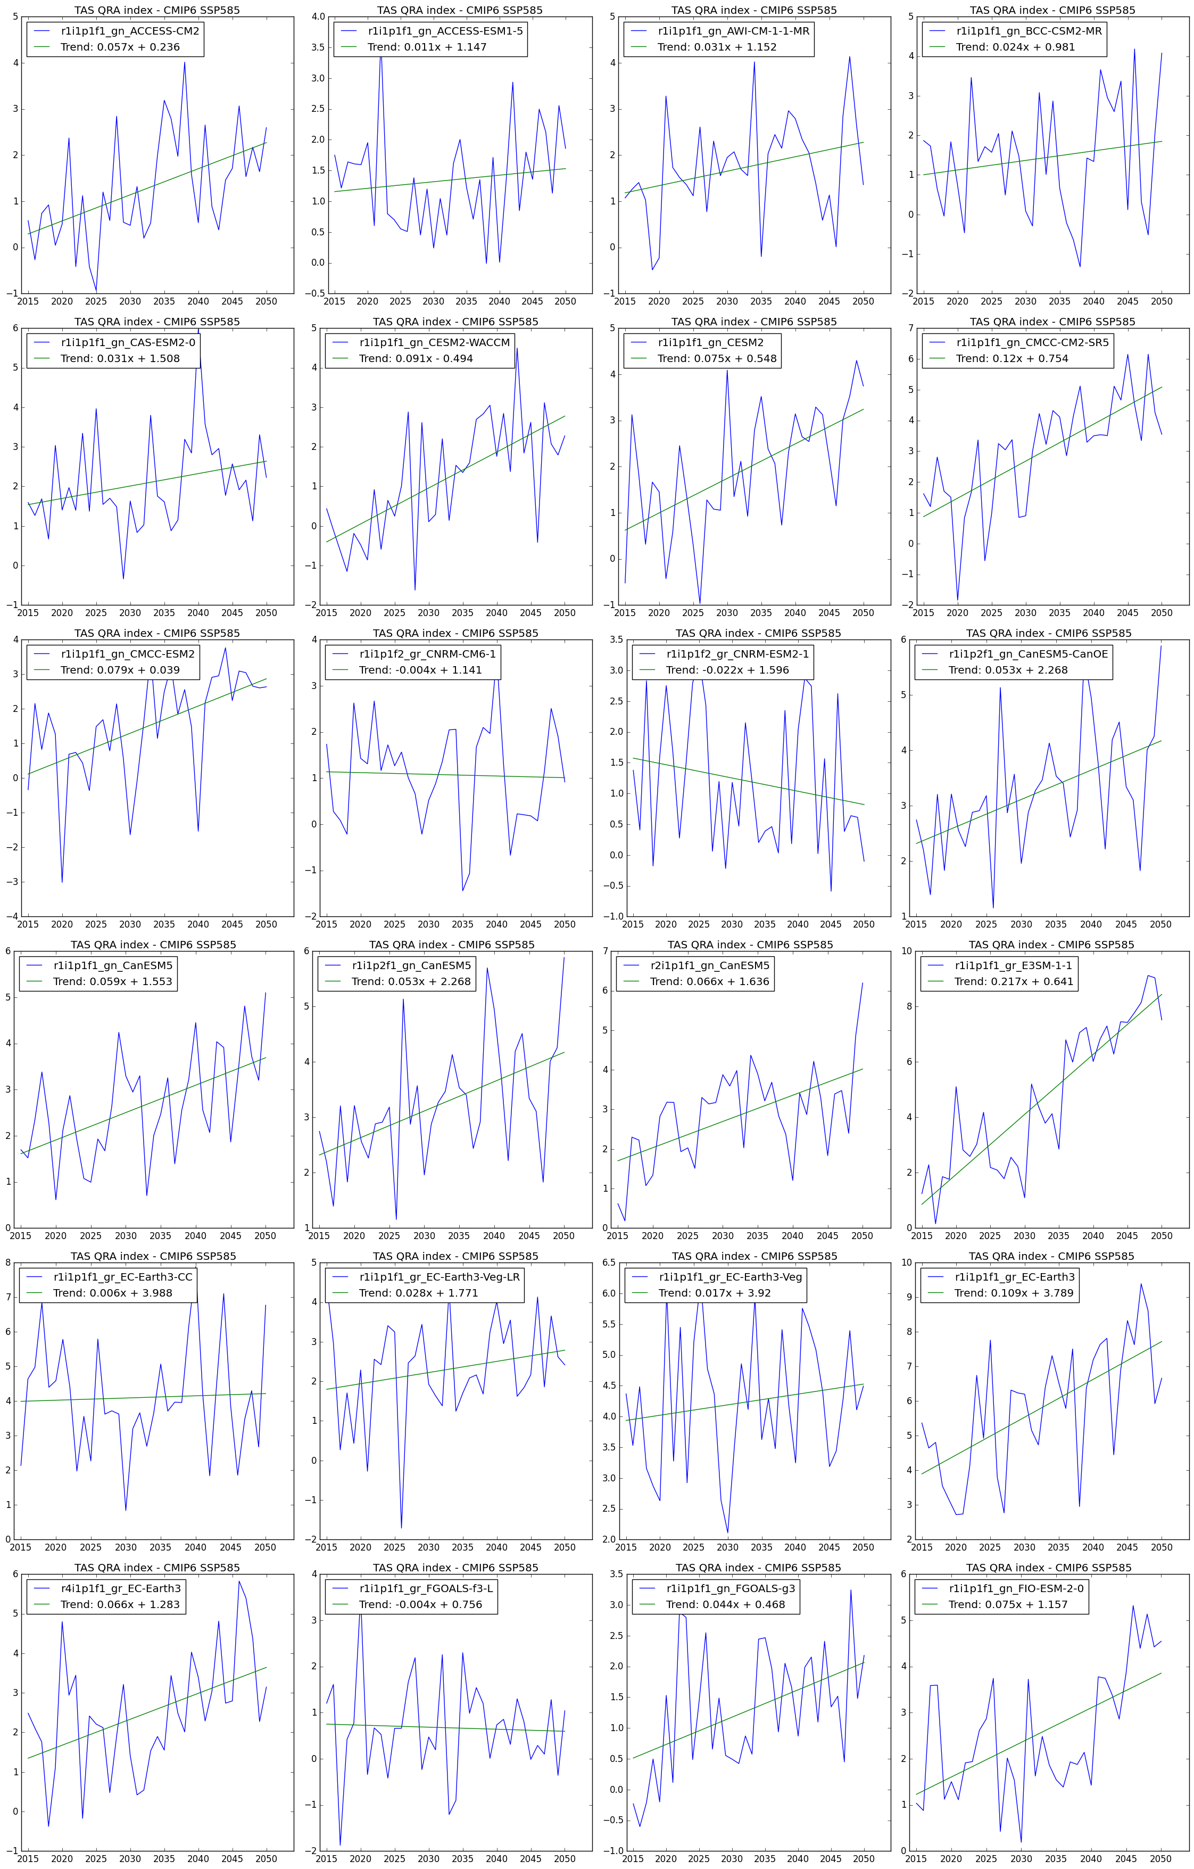

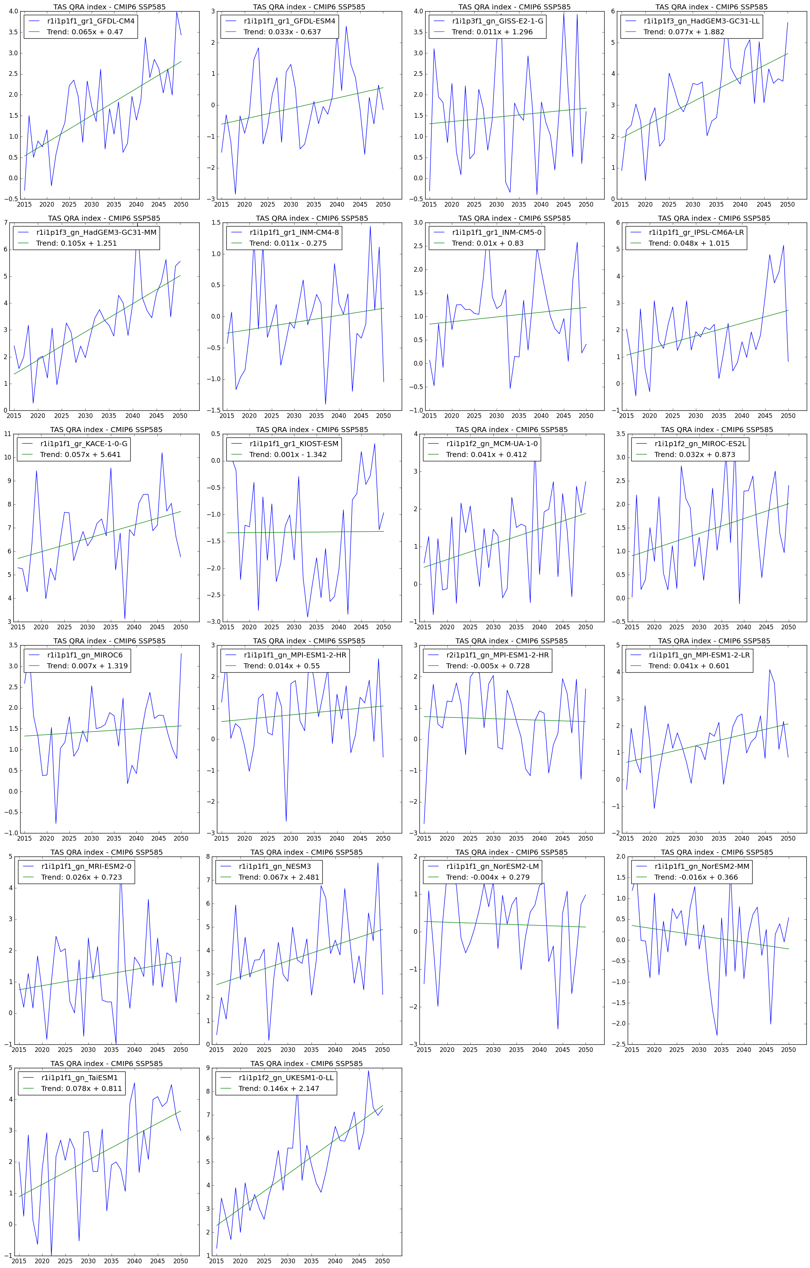

* 1. **CMIP6** – SSP585 -> Trend for 2051-2100

